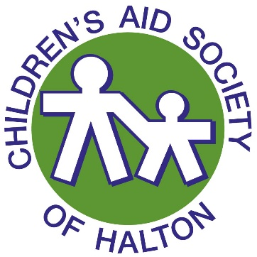
2023 Youth Awards
Nomination Form

Contact Information

Youth’s Name
Status  (please check one) |  | Youth in Care |  | Bridging the Gap |  |  |  | Volunteer Youth Service Agreement (VYSA)/Ready Set Go (RSG)
 |  | Other (please specify below)
Your Name/Email
 |  | (name) |  |  |  | (email)

Award Category (please select one)
Doug McPhie Award (Children’s Aid Foundation of Halton award)
Elizabeth Interiors Award (Children’s Aid Foundation of Halton award)
Youth in Action Award (Society award)
Youth Leadership Award (Society award)
Joan Marshall Achievement Award (Society award)
Scott Waterhouse Leadership in Equity and Inclusion Award (Society award)
Nancy MacGillivray Award (Society award)

Reason for Nomination
Please provide a brief description of why the nominee should receive the award, e.g., achievements, successes, contributions, etc. (continue on a separate sheet if necessary).

2023 Youth Awards
Nomination Form

Award Criteria
- Doug McPhie Award—the nominee should be currently attending a program or starting one in the fall, and has/or will be receiving a bursary from the Halton Children’s Aid Society, which is funded by the Children’s Aid Foundation of Halton. In addition, they show a strong sense of determination and passion for learning or have overcome challenges yet are able to keep a focus on completing their education. The recipient will receive $500 and a certificate from the Halton Children’s Aid Society as well as an engraved, glass award and certificate from the Children’s Aid Foundation of Halton.
- Elizabeth Interiors Award—the nominee should be currently attending a program and has/or will be receiving a bursary from the Halton Children’s Aid Society, which is funded by the Children’s Aid Foundation of Halton. In addition, they should be a student who has excelled in some capacity throughout their program, which does not need to be solely based on academic success, but could include community involvement, mentoring others or securing a placement/internship. The recipient will receive $500 and a certificate from the Halton Children’s Aid Society as well as an engraved, glass award and certificate from the Children’s Aid Foundation of Halton.
- Youth in Action Award—the nominee is a youth who exemplifies creativity and initiative. They are committed to making a difference through their education, career, volunteer work and/or community involvement. The recipient will receive $500 and a certificate from the Halton Children’s Aid Society.
- Youth Leadership Award—the nominee demonstrates a strong leadership role amongst their peers, takes responsibility for their actions, is resourceful and takes initiative. The recipient will receive $500 and a certificate from the Halton Children’s Aid Society.
- Joan Marshall Achievement Award—the nominee participates in community events, regularly volunteers their time and takes a leadership role to get others involved. The recipient will receive $500 and a certificate from the Halton Children’s Aid Society.
- Scott Waterhouse Leadership in Equity and Inclusion Award—the nominee demonstrates sensitivity to inequity and takes action to promote change for those in the LGBTQ+ community, racialized communities, the Indigenous community, mental health care recipients, those living with physical disabilities, those living in poverty and/or any marginalized group that encounters inequitable treatment. The recipient will receive $500 and a certificate from the Halton Children’s Aid Society.
- Nancy MacGillivray Award—the nominee should be a student or parent in the community who is continuing to pursue their education or skills. This does not necessarily need to be solely based on academic success, but could include commitment to strive for improving their quality of life or community involvement. The recipient will receive $500 and a certificate from the Halton Children’s Aid Society.

Please submit completed nomination form(s) to
Aidan O’Sullivan De Peza
or Greg Wootten
Nominations close at
4:30 pm on Friday, May 26, 2023

